**E-COMMERCE SALES AND PRODUCT DEMAND PREDICTION​**

**​**

MACHINE LEARNING – 18CSC383​

Ms. PRAJNA DORA​

AASHIKA B S CB.SC.I5DAS19003​

DHANUSHRI M CB.SC.I5DAS19015

KEERTHANA PRIYA D CB.SC.I5DAS19018​

SHIVADA K P CB.SC.I5DAS19028

**DESCRIPTION:**

Ecommerce is a platform where people buy and sell products conveniently from anyplace or anytime. So, in order to make this experience even better and to improve the profit of the company machine learning approach is taken. E-commerce sales and product demand prediction project focuses on predicting the profit. It also predicts the demand of each product depending upon the customer’s needs. This project also predicts which city will have the maximum sales.

**MOTIVATION:**

People don’t just shop from home; they are making purchases anywhere they have Wi-Fi or phone service. Sixty-two percent of smartphone users have made a purchase online using their mobile device in the last six months. Selling via online increases reach of products.

By incorporating machine learning in e-commerce sector, meaningful insights can be drawn by the business stakeholders and they can make necessary changes to improve their business.

* Determine incremental impacts of new initiatives
* Project future budgets
* Reduced spoilage and fresher, more appealing products through more accurate stock allocation

It will surely create impact on lots of manufactures who uses sales and each and every manufacturer in the world to optimise their inventory and they can get reasonable estimate for their production.

**DESCRIPTION OF DATASET:**

This project uses a dataset from an e-commerce website. The dataset has information of 25035 orders from 2011 to 2014 made at multiple marketplaces in the world. Its features allow viewing an order from multiple dimensions**.**

**NO OF ATTRIBUTES:**

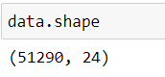

**ATTRIBUTES IN DATASET:**

Row ID, Order ID, Order Date, Ship Date, Ship Mode, Customer ID, Customer Name, Segment, City, State, Country, Postal Code, Market, Region, Product ID, Category, Sub-Category, Product Name, Sales, Quantity, Discount, Profit, Shipping Cost, Order Priority.

**TO PRDEICT PROFIT:**

**NO OF ATTRIBUTES:** 8

**KIND OF ATTRIBUTES**:

**DEPENDENT ATTRIBUTE**: Profit

**INDEPENDENT ATTRIBUTE:** Order date, Ship Date, Discount, Quantity, Shipping   Cost, Sales

**NATURE OF OUTPUT**:

**REGRESSION MODEL:** Profit – Numerical values

**TO PREDICT DEMAND:**

**NO OF ATTRIBUTES:** 10

**KIND OF ATTRIBUTES**:

**DEPENDENT ATTRIBUTE:** Product Name

**INDEPENDENT ATTRIBUTE:**Order date, Ship Date, Discount, Quantity, Shipping   Cost, Sales, Country, City, State

**NATURE OF OUTPUT**:

**CLASSIFICATION MODEL:** Product Name – Categorical value

**SAMPLE DATA:**

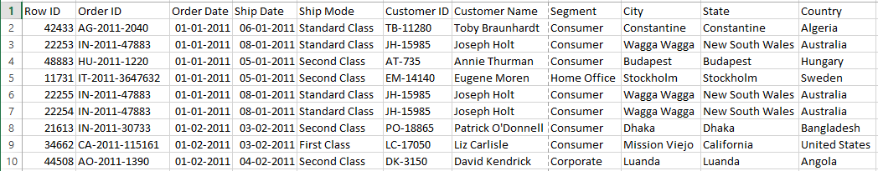

**LINK TO DATA:**

<https://www.kaggle.com/jr2ngb/superstore-data>

**CHALLENGES:**

Dataset of the e-commerce is too vast to analyse and draw insights from it. Start-up cannot predict the profit and demand of products due to lack of knowledge. Without proper sales forecasting, many business decisions are based on unreliable estimates or instinct – which leads to many inefficiencies and missed opportunities.

**ALGORITHM:**

* **Predicting profit:**

      Linear Regression, Random Forest

* **Product Demand:**

    Random Forest, K-NN